COLLEGE
EVENT

Monday, October 15, 2018
6:30 PM
Douglas S. Freeman High School
Auditorium
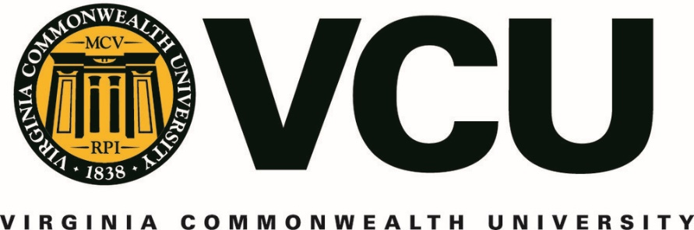
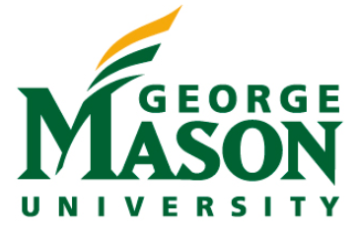
Admissions Counselors from George Mason University and Virginia Commonwealth University will be here to talk about their school and admissions requirements.

